 AI ENABLED CAR PARKING USING OPEN CV

## A PROJECT REPORT

***Submitted by***

|  |  |
| --- | --- |
| **ARJUNAN B** | **715320121003** |
| **AMIRTHARAJ A** | **715320121001** |
| **ASHOK A** | **715320121005** |
| **ARULPANDIYAN A** | **715320121004** |

***In a partial fulfillment for the award of the degree Of***

# BACHELOR OF ENGINEERING IN

**NAAN MUDHALVAN**

# ASIAN COLLEGE OF ENGINEERING AND TECHNOLOGY, COIMBATORE-641 110.

**2020 - 2024**

ANNA UNIVERSITY: CHENNAI 600 025

# BONAFIDE CERTIFICATE

Certified that this project report **“AI ENABLED CAR PARKING USING OPEN CV”**is the Bonafide work of the following students,  **ARJUNAN B (715320121003), AMIRTHARAJ A (715320121001), ASHOK A** **(715320121005), ARULPANDIYAN A (715320121004)** in partial fulfillment for the award of the  **NAAN MUDHALVAN** and the project work is carried out under my supervision.

# ACKNOWLEDGEMENT

This satisfaction and successful completion of any task could be incomplete without mentioning the people who made it possible, whose constant guidance and encouragement crown our efforts with success.

We take the opportunity to express our grateful acknowledgement to

**Mr,SELVARAJ Chairman** of asian college of Engineering and Technology, Coimbatore for the facilities provided to do this project.

We also express our heartiest thanks to **Dr.C.V SARAVANAN Principal**, asian college of Engineering and Technology, Coimbatore for approving this project.

We express our sincere gratitude to **Mr.S.CHANDRU(SPOC)** for his extended co-operation, concern and his persistent encouragement and support.

We wish to express our hearty thanks and sincere acknowledgement to our project guide **Mr. K.DURAIRAJ.BE,M.E. MECH** for his concern about the project and timely help to direct us for every move in this project.

We express our sincere and deep gratitude to our beloved assistant professors and technicians for their kind co-operation, moral support and encouragement for completing this work. We express our thanks to all those who helped us directly or in directly in the successful completion of this project work

**TABLE OF CONTENTS**

1. INRODUCTION
   1. .Project Overview
   2. .Purpose

**2 .**LITERATURE SURVERY

2.1.Existing problem

2.2. Referances

2.3.Problem Statement Definition

3. IDEATION AND PROPOSED SOLUTION

3.1. Empathy map Canvas

3.2.Ideation & Brainstorming

3.3.Problem Solution

3.4. Problem Solution fit

4.REQUIREMENT ANALYSIS

4.1. Functional requirement

4.2. Non Functional requirements

5.PROJECT DESIGN

5.1.Data Flow Diagrams

5.2. Solution &Technical Architecture

5.3.User Stories

6. PROJECT PLANNING & SCHEDULING

6.1.Sprint Planing & Estimation

6.1.Sprint Delivery Schedule

6.3.Report from JIRA

7. CODING & SOLUTIONING

7.1. Feature 1

7.2.Feature 2

7.3. Database Schema

8.TESTING

8.1.Test Cases

8.2.User Acceptance Tasting

9.RESULTS

9.1. Performance Metrics

10.ADVANTAGES DISADVANDVANTAGES

11.CONCLUSION

# ABSTRACT

A problem of finding an appropriate parking space is a challenging one, particularly in large cities. With the increase in car ownership, parking spaces have become scarce. The growing demand for these spots coupled with limited availability has led to imbalances between supply and demand. A lack of adequate parking management systems has resulted in many streets being littered with illegally parked cars. A scalabl, reliable, and efficient parking management system is needed to combat this problem. Deep learning-based computer vision techniques have emerged as promising solutions for such problems. These technologies have had a huge impact on the field of image recognition and processing. They also present great potential for further applications in the area of vehicle tracking. Hence, they can be used to detect parking spots.

A densely packed city center can be an unbearable place to park your car. Finding parking spaces can prove frustrating if you're not careful. Automatic smart parking systems promise to ease the burden of finding a spot in busy areas. To help drivers find a parking spot, we have developed a vision-based smartparking framework. First, we divided the parking lot into blocks and categorized each block to determine whether it was occupied or empty. Then we sent information about the availability of free or reserved parking to motorists on their smartphones. Our system demonstrates superior performance compared to commercially available solutions because it offers higher accuracy.

**1.INTRODUCTION**

## 1.1.Project Overview

Most parking lots today are still managed by hand. There is no automated monitoring system in place to keep track of how much capacity each parking place contains. In order to find an empty spot, drivers often have to make a circuitous trip through the parking lot. Where there are more people

than parking spots, such problems are especially common near hospitals, malls, schools, and other large gathering places.

The process of finding a free parking space can take a lot of time and involve driving around in circles. These days, parking spots are often occupied so badly that they’re almost unusable. Poorly managed parking areas lead to inefficient utilization of the parking spaces. This causes a lot of traffic jams near the parking areas. We propose a new method to improve the efficiency of parking lots by counting how much space is left in each parking zone and displaying that information to drivers via a smartphone app. We employ a camera to photograph the parking lot and use image processing approaches to determine if any vehicles are parked in each section. Whenever a vehicle moves into or out of a particular parking zone, the status of the whole lot changes.

Concrete is the most adaptable construction material as it can be designed to withstand tough environments. Conventional concrete consist of fine aggregate (sand), coarse aggregate (gravel) and binder material (cement).Excessive consumption of construction materials roots for the growth in demand of these materials. This massive demand compels the usage of alternate materials in concrete. Another major problem is that newer wastes are generated day by day on a bulk basis.

The process of finding a free parking space can take a lot of time and involve driving around in circles. These days, parking spots are often occupied so badly that they’re almost unusable. Poorly

managed parking areas lead to inefficient utilization of the parking spaces. This causes a lot of traffic jams near the parking areas. We propose a new method to improve the efficiency of parking lots by counting how much space is left in each parking zone and displaying that information to drivers via a smartphone app. We employ a camera to photograph the parking lot and use image processing approaches to determine if any vehicles are parked in each section. Whenever a vehicle moves into or out of a particular parking zone, the status of the whole lot changes.

The proposed approach can be digested into the following

steps:

Step 1: Detection of the parking spaces beforehand: The solution requires a manual step in which the technical support person for the solution needs to mark the parking spaces in each parking slot in the distributed parking system.

Step 2: Registration of the user to the solution: Since it is a web-based application, the user needs to register himself into the system to access the application. All the security aspects regarding registration will be taken care of in this module.

Step 3: Schedule Monitoring/Creation: Our approach is built based on a school-based prototype. Hence, the user can choose which classes he has enrolled in.

Step 4: Dynamic video updates: The video captured by the fixed camera needs to be saved and updated into the folder from which the solution can pick it up and render it.

Step 5: Slot detection: The user will be able to look at the current slots available and will be advised as to which slot he needs to park in as per his schedule [Step 3].

## 1.2 .OBJECTIVE[Purpose]

The main objective of the project is to

* Hook up a webcam to a snort Pi and have live parking monitoring at home.
* Almost parking lot video to have overview perspective(for clearer globules)
* The system presents the details of vacant parking areas nearby, and reduces the market problems related to illegal parking in the area. It was intended to meet the requirements of controlled parking that offers downhill parking techniques to the authorities

## CHAPTER – 2

## 2 .LITERATURE SURVEY

In this paper , for an autonomous vehicle parking system , we have created and implement framework. The experimental results demonstrated the suggested system's ability to provide accurate data. The issue of parking in crowded regions has been addressed using a variety of strate giesand forms. Approach for counting the cars at the checkpoint from which the variety of open parking spots can be counted was once proposed via Ming- l. Induction loop sensors are positioned below the road surface to elevate out the counting.[11] Although the usage of sensors was once much less highly-priced, they aren't fluently told by environmental factors, andthey reliably detect, their installation was challenging and resulted in road damage. In the event of a problem, maintenance was extremely grueling . Grounded on vision- based techniques, various categories of discovery styles are described. The entire parking lot that's open for parking can beanal ysed by the camera using vision- grounded

ways; the facts is also analysed, and the output will specify the unique quantity and regions of the open parking spaces. According to Zhang Bin e.[4], vision- grounded parking spot detection techniques are relatively simple to set up, inexpensive, and the detector can be quickly modified to meet needs. also, the information gleaned from photographs is quite rich.The precision of the vision approach is severely reliant on the camera's position

## 2.1.Existing problem

Videos were recorded using a camera that was ten feet above the parking lot. In order to ameliorate the system's ability to recognise objects, video footage was collected under various environmental and temporal situations. Frames are used to segment video. also, to reduce computational complexity, a key frame is uprooted from each segment and subjected to additional processing. Key frame subtraction is used to estimate the motion of the toy auto when it enters or exits the parking lot from the parking arena. must manually enter the location of the intended parking spotand the car. The system automatically creates virtual parking spaces while taking the size of the vehicle into consideration. In our training model, the number of parking spaces is limited to fourteen. Each parking lot has a different numeric label, ranging

. Our system will check to see if there are any cars in each block after the parking area has been partitioned into virtual blocks. Inverse binary is used to take out the car as the area of past time ROI after applying a binary filter to the image. Calculating the connected region's value in ROI and designating a parking space as reserved when the threshold value exceeds eighty. The count of unreserved sections will be displayed to drivers in green, while the number of reserved sections will be displayed in re

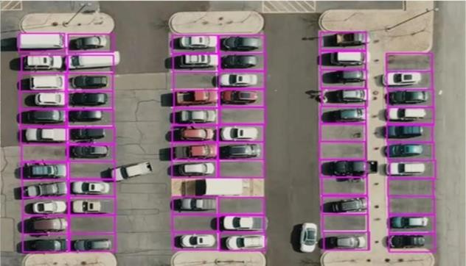

**2.2.Referances**

For this particular prototype, we have evaluated our solution with two parking blocks which make up the distributed parking management system. Each parking block has a different number of slots and this has been taken into consideration for similarity issues. The evaluation results for both the slots have been recorded and mentioned below. The classes have reacts to it. For a majority of th cases, the solution is able to determine which slot is near for the particular user based on his schedule and provide a suggestion. The suggestion also depends on the current time when the user asks to provide a suggestion as well. The solution assumes a few suggestions to be true and there is a limit on it as well. So, as part of further implementations , a generalization of the suggestions can be embedded and decisions can be made accordingly

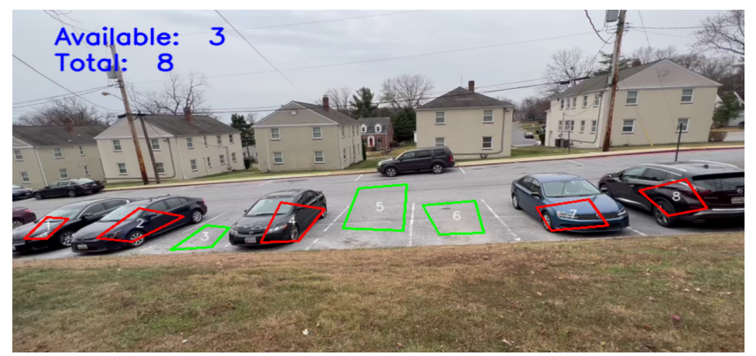

**2.3.Problem Statement Definition**

1. Open C V- python Open CV, a sizable open- source library for computer vision, machine erudition, and image processing, currently plays a significant part in real- time operation, which is crucial in modern systems. It can be used to process picture sand pictures so that people can fete goods, people's faces, and even human handwriting. The Open CV array structure can be reclaimed by Python for figure out when it's coupled with a variety of libraries, cognate as Numpy. We use vector space and implement fine activities to the aspects of a visual pattern in order to identify it.

2. Spot Pickle is mostly used in Python to serial and non sequential Python object formats. To place it different way, it’s the procedure about converting a Python object into a byte run so that it can be saved in a column or memory, have its state preserved across sessions, or be used to transfer data over network. By using the pickled byte stream and besides un pickling it, the original object hierarchy can be recreated. Object in Java or.Net is correspondent to this entire process

3.CV zone : This computer vision package facilitates the implementation of AI and image processing operations. It primarily makes use of the Open CV and Media pipe libraries

1. Num Py : For the Python programming language, Numpy Is a library that adds support for largish , multi-layered arrays and matrices. It additionally affords a big count of high-stage mathematical features to work with these arrays.

5. cv2 library Open CV has a function called cv2 that can read tape recording(). Pass 0 in the function parameter allows us to penetrate our webcam. The RTSP url can be dispatched .

6. Py charm or other IDE( is recommended) Py Charm is a specialized Python Integrated Development Environment( IDE) that gives a vast range of crucial equipment for Python developers.

## 3.IDEATION AND PROPOSED SOLUTION

The primary route-way of the proposed algorithm for parking space discovery are

1. The parking lot will be live- streamed by the camera to the

system.

2. When a horseless carriage pulls into or out of the parking space,

Film making are taken.

3. Grayscale images are created by converting RGB images.

4. Make adjustments Choosing the parking lot's equals first is a good idea. This will remove any unnecessary white space from the image other than the parking lot.

• Next, decide where the single parking space's parallels are. As a result, the parking lot will bedivided into spaces of cognate size.

5. In order to turn the parking lot into black and the auto into white, each block is first converted from grayscale to double and then to inverse binary.

6.To determine if a block contains a car or not, a threshold values computed for each block. Blocks are free and available for parking if their value is less than a threshold value, and they're occupied if their worth exceeds the threshold

**3.1. Empathy map Canvas**

Parking detecting systems were built in the early 2000s using traditional hand-crafted elements. The majority of the current solutions rely on sensors to determine whether each parking space is occupied. Static traffic refers to car parking, which includes both short-term parking for passengers hopping on and off, as well as long-term parking in parking areas. Design and layout, insufficient regulation of land use indicators, fewer parking spaces in parking lots, fewer parking spaces in public buildings, and a severe road occupation phenomenon are all examples of static difficulties. The above situation demonstrates that the parking problem is very acute. Design and layout issues, inadequate control of property use metrics, very few parking spaces in parking areas, very few parking areas in public buildings, as well as an extreme road occupation phenomenon are all examples of static traffic issues. The above situation demonstrates how serous s the parking issue is. As a result, enhancing parking spot detecting technology has risen to the top of the priority list of parking issues. Studies have discovered numerous parking space recognition methods to enable drivers to park and access the garage more swiftly with real-time parking space data in recent times, with the continuous development of parking space detection methods. Researchers have developed a range of parking space detection techniques, which can be split into fully automatic and semi-automatic detection techniques, as a result of the fast development in need for parking assistance systems in the last couple years. There is no need for manual intervention when using completely automatic parking space detecting systems. This device detects the required parking place and chooses it for you automatically. However, because all of the recognized parking space kinds are preset, there are severe limitations on the type s of parking spots available inside. This system is unable to detect that it is outside of the specified range. The semi-automatic parking space detection approach, on the other hand, necessitates human-computer interaction during the parking space identification process to complete the recognition of available parking lots. As it has more information from the user, the semi-automatic approach may yield more reliable outcomes and utilize less computing resources than the fully automatic method. For instance, Toyota’s IPA (Intelligent Parking Assist System) is a classic semi-automatic parking

## 

## 3.2 .Ideation & Brainstorming

These photos are standardized, and then a couple of ROI are added to each partition of the parking space, increasing the accuracy of vehicle detection describes an image processing approach for detecting whether a parking division is available or allocated by capturing the dark circle printed on the parking space and processing it. In a car image is recorded as a reference image, and the other pictures are matched with the source images using an edge detection approach, displaying information about available and occupied spots. Several approaches for extracting features.

**3.3. Problem Solution**

Coarse aggregates refer to irregular and granular materials such as sand, gravel, or crushed stone, and are used for making concrete. In most cases, Coarse is naturally occurring and can be obtained by blasting quarries or crushing them by hand or crushers. It is imperative to wash them before using them for producing concrete. Their angularity and strength affect the concrete in numerous ways. Needless to say, the selection of these aggregates is a very important process.

## 3.4.Problem Solution fix

majority of the current solutions rely on sensors to determine whether each Parking detecting systems were built in the early 2000s using traditional hand-crafted elements. The parking space is occupied.

Static traffic refers to car parking, which includes both short-term parking for passengers hopping on and off, as well as long-term parking in parking areas. Design and layout, insufficient regulation of land use indicators, fewer parking spaces in parking lots, fewer parking spaces in public buildings, and a severe road occupation phenomenon are all examples of static traffic difficulties. The

above situation demonstrates that the parking problem is acute. Design and layout issues,inadequate control of property use metrics, very few parking spaces in parking areas, very few parking areas in public buildings, as well as an extreme. road occupation phenomenon are all examples of static traffic issues. The above situation demonstrates how serious the parking issue is. As a result, enhancing parking spot detecting technology

**4.REQUIREMENT ANALYSIS**

Parking detecting systems were built in the early 2000s using traditional hand-crafted elements. The majority of the current solutions rely on sensors to determine whether each parking space is occupied. Static traffic refers to car parking, which includes both short-term parking for passengers

hopping on and off, as well as long-term parking in parking areas. Design and layout, inefficient regulation of land use , fewer parking spaces in parking lots, fewer parking spaces in public buildings, and a severe road occupation phenomenon are all examples of static traffic difficulties The

above situation demonstrates that the parking problem is very acute. Design and layout issues, inadequate control of property metrics, very few parking spaces in parking areas , very few parking areas in public buildings, as well as an extreme road occupation phenomenon are all examples of static traffic issues. The above situation demonstrates how serious the parking issue is. As a result, enhancing parking spot detecting technology has risen to the top of the priority list for easing parking issues. Studies have discovered numerous parking space recognition to enable drivers to park and access the garage more with real-time parking space data in recent times, with continuous development of parking space detection methods. Researchers have developed a range of parking space detection techniques, which can be split into fully automatic and semi-automatic detection techniques, as a result of the fast development in need for parking assistance systems in the last couple years. There is no need for manual intervention when using completely automatic parking space detecting systems. This device detects the required parking place and chooses it for you automatically. However, because all of the recognized space kinds are preset, there are severe limitations on the types of parking spots available inside. This system is unable to detect that it is outside of the specified range. The semi-automatic parking space detection approach, on the other hand, necessitates human-computer interaction during the parking space process to complete the recognition of available parking lots. As it has more information from the user, the semi-automatic approach may yield more outcomes and utilize less computing resources than the fully automatic method. For instance, Toyota’s IPA (Intelligent System) is a classic semi-automaticparking

**4.1.Functional requirement**

A Smart way to manage car parking using Open CV. Using a smart parking system with image processing technique with [OpenCV](https://www.opensourceforu.com/2020/10/opencv-an-excellent-tool-for-computer-vision/" \t "https://www.electronicsforu.com/electronics-projects/prototypes/_blank). Now a days, a Smart Car Parking is must. The project involves a system including infrared transmitter and receiver at entry and exit gates and a boom barrier at gates can be powered by hydraulic system by a micro controller for car entry and exit. The Smart Car Parking System does all the required work like automatic counting, and opening and closing of the gates without human intervention. When the parking space is full, the gate barrier does not open and 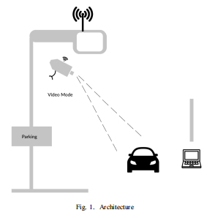

## Dependencies

* Python 3.6
* Tensorflow ≥1.3.0
* Open CV
* Matplotlib

## Shapely

## 1. Detection Of Parking Spots

The very first step in a parking space detection system is to identify the parking spots. There are a few techniques to do this. For example, identifying the parking spots by locating the parking lines in a spot. This can be done using the **edge detectors** that Open CV provides. But the problem here is that all parking locations don’t have these -defined boundaries.

Another approach we can use is to assume that the cars that don’t move for a long time are in parking spaces. In other words, valid parking spaces are just places containing non-moving cars. But, this also doesn’t seem to be reliable. It may lead to **false positives** and **true negatives**.

So, what should we do when automation doesn’t seem reliable? We do it manually. Unlike **space-based methods** that require **labeling** and **training** for every distinct parking facility, we only need to mark out parking lot boundaries and surrounding road areas once to configure our system for a new parking facility.

Here we will take a frame from our video/stream of the parking location and we will mark the parking regions. Python library **matplotlib** provides a functionality called **Polygon Selector**. It does exactly what we need here. It provides the functionality to select the polygon regions.

I have made a simple python script to mark the polygon regions on one of the initial frames of our input video. It takes the path of video as an argument and saves the coordinates of selected polygon regions in a pickle file as the output.

## PROJECT DESIGN

**5.1 Data Flow Diagram**

As I mentioned earlier, to detect cars in a video we will use the **Mask-RCNN.**It is basically a **convolutional neural network** trained on millions of images and videos from several datasets, including the **COCO dataset**, to detect various objects and their boundaries.Mask-RCNN is built on the top of the **Faster-RCNN**object detection model.

In addition to the class label and bounding box coordinates for each detected object, Mask R-CNN will also return the pixel-wise mask for each detected object in an image. This pixel-wise masking is called **Instance Segmentation**. Instance segmentation powers some of the recent advances that we see in the field of computer vision, including self-driving cars, robotics, and more.

Here we will use the [**implementation of Mask-RCNN by matterport**](https://github.com/matterport/Mask_RCNN). The reason I am using M-RCNN is that it has very good accuracy and matter port’s implementation is very easy to use.

**M -RCNN** will be used on every frame of the video and it will **return a dictionary that contains the bounding box coordinates**, **masks of detected objects**, **confidence score for each prediction**, and **class_ids** of detected objects. Now using the class_ids we will filter out the bounding boxes of the cars, trucks, and buses. Then we will use these boxes in the next step to calculate the IoU.

The output of M -RCNN

Check out this official **[IPython Notebook](https://github.com/matterport/Mask_RCNN/blob/master/samples/demo.ipynb" \t "https://medium.com/the-research-nest/_blank)** tutorial to understand the **API** of **M -RCNN**.

**5.2 Solution & Technical Architecture**

Intersection over Union is simply an **evaluation metric**. As its name suggests it the ratio of the **area of overlap**and **area of intersection.** Computing Intersection over Union can, therefore, be determined

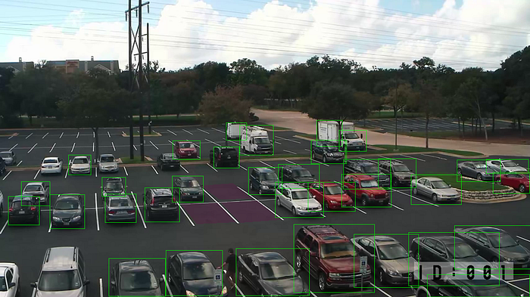

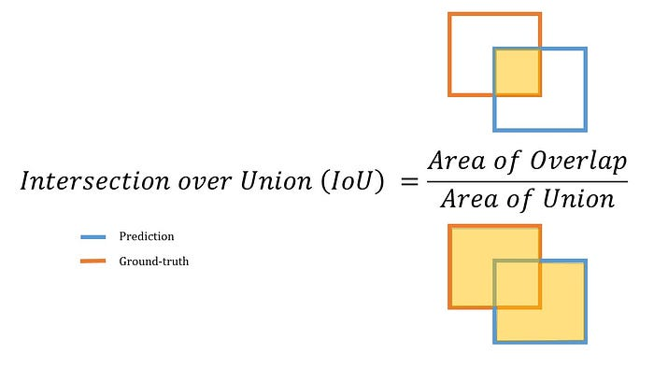

As I said earlier, we will compute the IOU for every pair of parking spot coordinates and bounding box of cars.**If the I for a pair is higher than a certain threshold, we will consider that parking spot as occupied**.

To calculate IOU we are going to use a python library called **Shapely**. It comes with an easy to use API that we will use to calculate the area of intersection and area of the union of two polygons.

**5.3 User Stories**

*Overall Framework Design of Parking System* (e parking system designed in this study is mainly divided into two parts: server part and data analysis part, including service application layer, perception layer, data analysis layer, and management layer [10]. (e function of the service layer is that users can obtain some relevant information such

as the number of cars in the parking lot, the entrance and exit of the parking lot, the estimated parking time, and so on, through the handheld terminal. At the same time, it also has

the distance navigation function, which can plan the optimal path to the entrance of the parking lot and record the location information and parking time of the parking lot. (e

main function of the front-end perception layer is information transmission. (e specific working principle is to obtain the recognition image of the parking space through the shooting function, recognize the coordinate information of the target parking space, and upload the information to the intelligent terminal. Combined with the positioning and

navigation system of the intelligent terminal, the information is judged and analyzed, and the path is calculated. Cloud service layer, also known as data analysis layer, analyzes and

calculates the obtained data by building a distributed cluster. In this study, the improved neural network algorithm and image recognition technology convolution neural network algorithm are used to analyze and process the data [11]. (e main function of management is to manage, monitor, and maintain all levels. (e system framework is shown in Figure 1.

(e network system of parking system is opm15 system, which is composed of multiple network intelligent terminals with sensing ability, processing ability, and wireless communication performance, and can realize the interconnection communication between objects and between objects and networks [12]. Nodes in omp15 network can also be used as relay signals of other base stations to dynamically use network resources. (e circuit connection diagram is shown in Figure 2. It can be seen from Figure 2 that the power supply voltage of opm15 module is 3.3 V, the magnetic bead device with anti-high-frequency interference is set, and the reset I/O is set, which can send reset command and reset with one key. Receive External Data (RXD) and Transmit External Data (TXD) serial port can realize the communication of

single chip microcomputer, as a terminal or router, and can

also realize the communication of Personal Computer (PC),

as a data communication acquisition and processing

module.

***2.2. Parking Space Recognition Technology Based on Convolution Neural Network Algorithm***

*.*  first step of automatic parking is to detect, identify, and locate the free parking space in the parking lot to get the real-time occupancy information. In this study, C N N algorithm is used to extract the features of the collected parking image, identify the vehicle target, and then judge the parking occupancy [13]. (e specific process is shown in

**Figure 3.**

(e feature extraction and recognition process is shown in Figure 3. (e algorithm adopted by the feature extractor is the multi layer CNN's algorithm. (e feature extraction process is to extract the overall image features first and then create candidate regions [14]. As shown in the figure, CNN's feature extractor selects conv5 convolution layer in Visual Geometry Group (VGG16) network to output feature map and generate candidate region of interest (ROI). (en, ROI is combined with corresponding feature map to be clipped to form target feature block. After ROI pooling, feature blocks are transformed into fixed size and enter the full connection layer. (en they are classified and located in the full connection layer, and the classification and recognition results are obtained.CNN model can accurately identify parking spaces, but the real-time performance is poor. (is study will improve the conventional neural network recognition

model and establish a one-time deep learning framework

7.CODING &SOLUTIONING

7.1 Feature 1

* Hook up a webcam to a snort Pi and have live parking monitoring at home
* chemical parking lot video to have overview perspective(for clearer globules)
* It’s effective at resolving parking issues. In addition, it provides automatic billing, as well as eliminating traffic congestion. Utilizing a multilevel parking technique, this work can be further developed into a fully automated system

7.2 Feature 2

* The system presents the details of vacant parking areas nearby, and reduces the market problems related to illegal parking in the area. It was intended to meet the requirements of controlled parking that offers downhill parking techniques to the authorities

8.TESTING

8.1 Test Cases

* The primary route-way of the proposed algorithm for parking space
* discovery are
* The parking lot will be live- streamed by the camera to the
* system.
* When a horseless carriage pulls into or out of the parking space,
* filmmaking are taken.
* Grayscale images are created by converting RGB images.
* Make adjustments
* Choosing the parking lot's equals first is a good idea. This will
* remove any unnecessary white space from the image other than
* the parking lot.
* Next, decide where the single parking space's parallels are. As a
* result, the parking lot will be divided into spaces of cognate size.
* In order to turn the parking lot into black and the auto into
* white, each block is first converted from grayscale to double and
* then to inverse binary.
* To determine if a block contains a car or not, a threshold values
* computed for each block. Blocks are free and available for
* parking if their value is less than a threshold value, and they're
* occupied if their worth exceeds the threshold.

DETECTOR CODE

**App.py**

|  |  |
| --- | --- |
| **import cv2**  **import numpy as np**  **import pickle**  **from src.utils import Park_classifier**  **def demostration():**  **"""It is a demonstration of the application.**  **"""**  **# defining the params**  **rect_width, rect_height = 107, 48**  **carp_park_positions_path = "data/source/CarParkPos"**  **video_path = "data/source/carPark.mp4"**  **# creating the classifier instance which uses basic image processes to classify**  **classifier = Park_classifier(carp_park_positions_path, rect_width, rect_height)**  **# Implementation of the classy**  **cap = cv2.VideoCapture(video_path)**  **while True:**  **# reading the video frame by frame**  **ret, frame = cap.read()**  **# check is there a retval**  **if not ret:break**    **# prosessing the frames to prepare classify**  **prosessed_frame = classifier.implement_process(frame)**    **# drawing car parks according to its status**  **denoted_image = classifier.classify(image=frame, prosessed_image = prosessed_frame)**    **# displaying the results**  **cv2.imshow("Car Park Image which drawn According to empty or occupied", denoted_image)**    **# exit condition**  **k = cv2.waitKey(1)**  **if k & 0xFF == ord('q'):**  **break**    **if k & 0xFF == ord('s'):**  **cv2.imwrite("output.jpg", denoted_image)**  **# re-allocating sources**  **cap.release()**  **cv2.destroyAllWindows()**  **if __name__ == "__main__":**  **demostration()** |  |

**Car parking.py**

**import cv2**

**from src.utils import Coordinate_denoter**

**def demostration():**

**"""It is the demonstration of the car_park_coordinate_generatorçpy .**

**"""**

**# creating the Coordinate_generator instance for extracting the car park coordinates**

**coordinate_generator=Coordinate_denoter()**

**# reading and initialing the coordinates**

**coordinate_generator.read_positions()**

**# setting the initial variables**

**image_path = "data/source/example_image.png"**

**rect_width, rect_height = coordinate_generator.rect_width, coordinate_generator.rect_height**

**# serving the GUI window until user terminates it**

**while True:**

**# refreshing the image**

**image =cv2.imread(image_path)**

**# drawing the current car park coordinates**

**for pos in coordinate_generator.car_park_positions:**

**# defning the boundaries**

**start = pos**

**end = (pos[0]+rect_width, pos[1]+rect_height)**

**# drawing the rectangle into the image**

**cv2.rectangle(image,start,end,(0,0,255),2)**

**cv2.imshow("Image",image)**

**# linking the mouse callback**

**cv2.setMouseCallback("Image",coordinate_generator.mouseClick)**

**# exit condition**

**if cv2.waitKey(1) == ord("q"):**

**break**

**# re-allocating the sources**

**cv2.destroyAllWindows()**

**if __name__ == "__main__":**

**demostration()**

**output:**

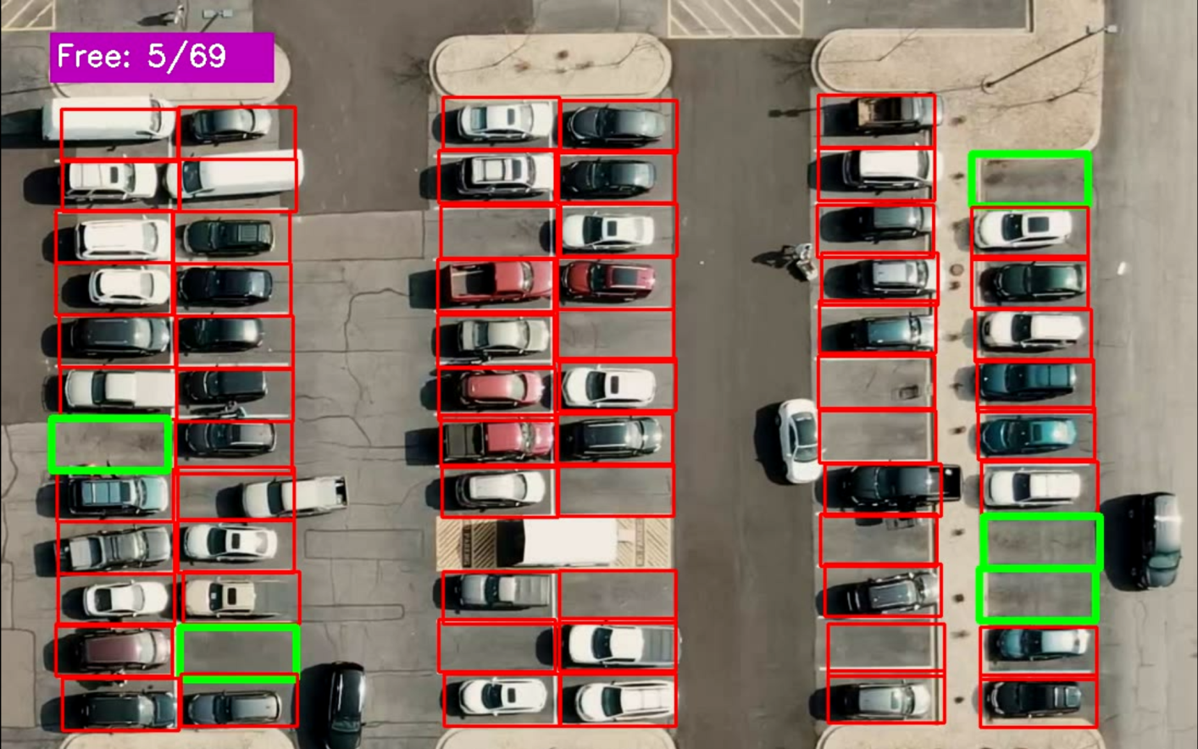

ADVANTAGES

* EFFICIENCY
* FASTER PROCESSES
* REPORT TRACKING

DISADVANTAGES

* EXPENSIVE CONSTRUVTION&INSTALLATION
* REQURIES REGULAR MAINTENANCE
* SYSTEM BREAKDOWN

ADVANTAGE

1.EFFICIENCY:

Manually handling parking is rarely as precise and efficient as some might think. The work requires a lot of focus, as it deals with managing a large volume of people simultaneously in the same place. And if you miss or ignore one of them during that time, it could result in fines or even an accident for them! Then you’ll have to deal with issues which would be much worse. You can avoid this by working with software instead; an **automated ticketing solution** is much more convenient for drivers and easy to use because they just need to get on their smartphone, enter their vehicle registration information, and drive into the car park. If a user wants to pay digitally, they can do so using their pre-registered credit card details; above all else, there are no mistakes allowed while parking!

1. FASTER PROCESSES:

Sometimes we get very bored and want to go home as quickly as possible. We are in a rush, and standing at the gates is a waste of our precious time. Are there any parking spaces available? Are my car keys still working? How many more minutes will I still have to wait? A lot of our thoughts race through our heads. Employees can now take advantage of the fantastic parking management systems to avoid the long line and wait for entry. These**parking solutions** can completely automate the parking process and make car parking time-efficient.

1. REPORT TRACKING

Present-day **parking management systems** don’t require paper and pencil, as everything is automated and can be outsourced to app-based reports. These parking systems allow managers to focus on more substantial tasks than counting vehicles or even one-on-one instances of people using a particular parking space. The app-based programs also make it easier for users to find and navigate free spaces by determining where they are. All in all, the **RFID technology** effectively gives both users and managers a fair share of advantages when it comes to monitoring and managing parking spaces vs keeping an accurate record of all vehicles that come in contact with the system.

DISADVANTAGE

1. EXPENSIVE CONSTRUCTION & INSTALLATION :

A parking management system can cost a lot of money. For example, the statistical feature,**ticketing technology**, and reporting tools are just some things that increase the price. In addition, the other things you might need to pay for include high usage or peak access fees, software maintenance fees, and fee waivers, to name a few. Your budget may not allow you to purchase everything at once, so make sure you prioritise your needs based on your organisation’s requirements.

2.REQUIRES REGULAR MAINTENANCE:

The parking systems are usually automated, but they require regular maintenance to ensure everything is working smoothly. This means ensuring the software isn’t broken, and everything works properly, such as updating portions of code or optimising tasks for quickness and efficiency. This could include updating portions of code or optimising the program in order to optimize tasks for speed, reliability, and efficiency. Regular maintenance of**parking systems** requires not only money but also time. Hence it could be considered a downside of having a parking management system.

3.SYSTEM BREAKDOWN :

Utilizing technology to manage a car park is unquestionably an excellent decision. Still, we cannot ignore that machines can start malfunctioning anytime, no matter how meticulously they are manufactured or what software they are integrated with. In these cases, chaos may occur. Imagine if cars couldn’t access buildings and parked inside vehicles couldn’t move. If the system malfunctions, this could lead cars to park in the wrong places. This is another considerable downside of using a**parking management system**

CONCLUSION

This study's main beneficence is to perfect the unearthing of open parking spaces in an expenditure to ease parking arena slowdown.The development of machine l and vision- grounded technology has made it possible for motorcars to find open spaces

at parking lots using affordable automatic parking systems.unborn studies can concentrate on assigning specific emplacements to customers who have registered with an online parking management system.The precision about the proposal algorithm is inaugurated to be

92.The outcomes demonstrates that, when the captured photos of the parking lot aren`t clear due to low lighting or overlaps, the productivity drops and the exactitude for spotting decreases. It’s

noticed that the average performance is 99.5 and is remark ably high as contrasted with other parking lot finding out procedures.The effectiveness of the proposed method in some cases drop down due to the strong darkness. The ultra precision of Get image frames RGB to Gray image Do Calibration Get equals of parking spot Get fellows of car Parking spot divided into Blocks Convert Block to inverse binary Get value of connected locality to determine autos number of free and Reserved Blocks Input Live stream recording 1313 the proposed task additionally relies on the kind of camera utilized for covering the parking lot.

DEMO LINK:

https://drive.google.com/file/d/1eWVoOzJfDGmdsoENl8doZYiU5AOpeaNA/view?usp=share_link